**TOYROBOT SOLUTION**

**IDE**: Visual Studio 2022

**API Testing** : Postman

Three projects are utilized in this setup:

1. **Console Application - ToyRobot.ConsoleApp:**
   * The console application not only displays the output in its console but also allows observation through Postman.
2. **.NET Core Application - ToyRobot.Core**:
   * This application processes commands and manages the position placement of the toy robot.
3. **.NET Core Web API Application - ToyRobot.WebApi:**
   * The Web API handles incoming API POST requests containing commands in JSON format. This interaction can be tested using an API testing tool.

To configure the startup projects:

* Select multiple startup projects and run the following applications:
  + **ToyRobot.ConsoleApp**
  + **.NET Core Web API**

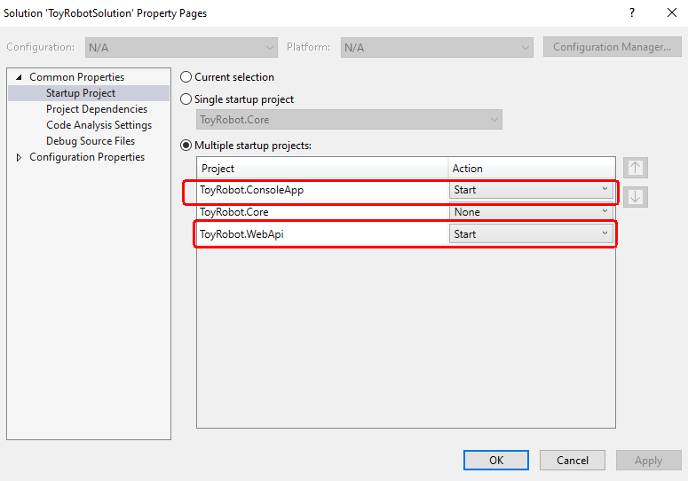

* After a successful run, you can submit commands via Postman to observe the corresponding output.

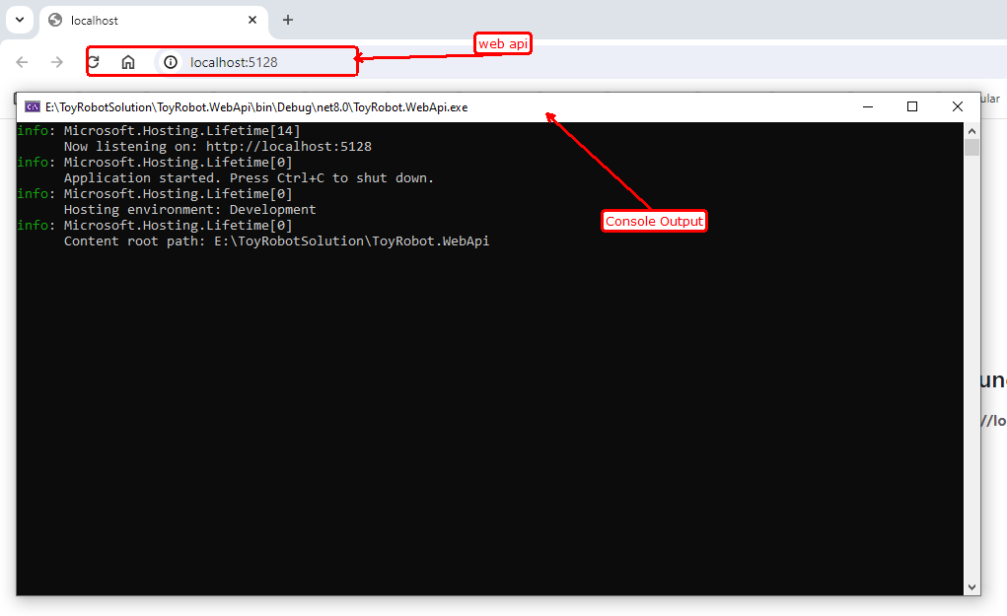

**Postman:**

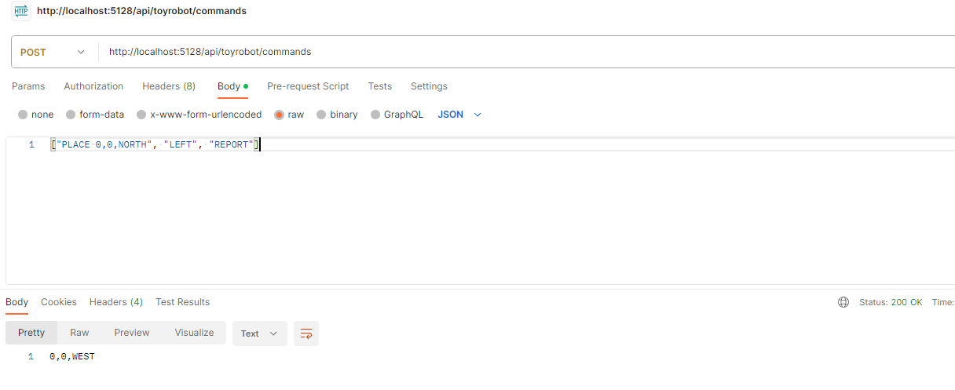

**Output In Console:**

